Nithin S
221IT085

IT150 Lab Assignment 9

Q1.Write a Java application that prompts the user for side length of a square and uses a method
called SquareArea to calculate the area of the square and uses a method SquarePerimeter to
calculate the perimeter of the square.
a) In the above program declare the side length with ‘a’ and create multiple objects
to create the area and perimeter of the square.
b) Create a Rectangle class equivalent to the Square class created as above. Before
coding the class, decide which variables and methods this class must have.
c) Create a class called TestQuadrilaters that prints the details of a square and a
rectangle

Code

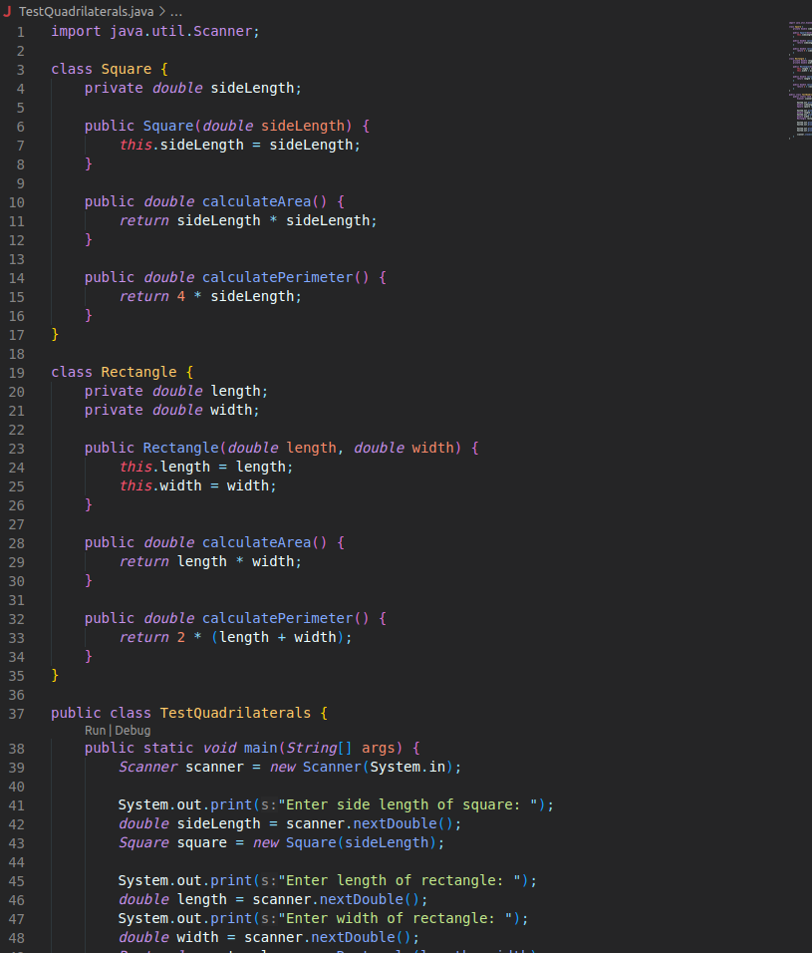

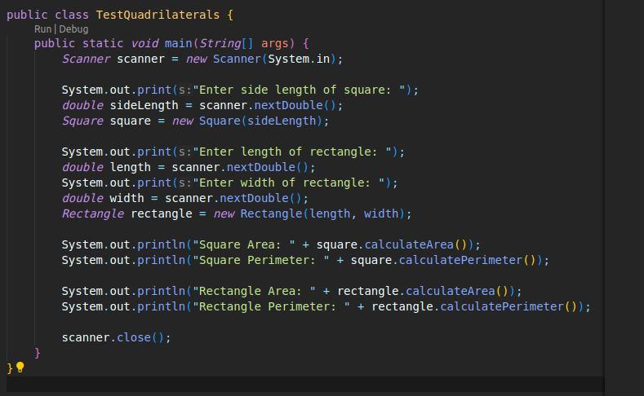
OUTPUT

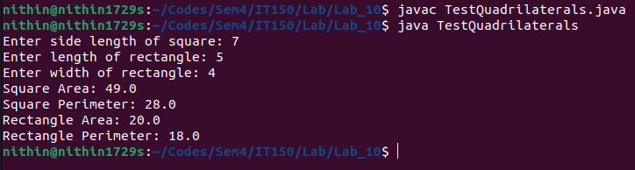

Q2.Write a JAVA program to create a Mydetails with data members Roll no, name and department.
The constructor Mydetails () should initialize the Roll no, name and the department. The member
function display() should display the values of Roll no, name and the department. In the main()
method, an object ‘m’ of class Mydetails to be created with values 1010,”xxx” and “xxdeptxx”.
Then the display() method should be called.

Code

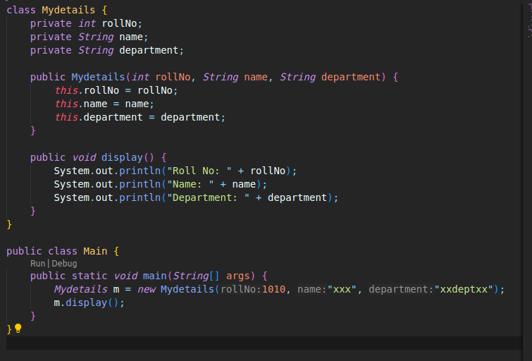

OUTPUT

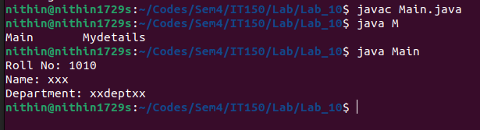

Q3.Write a JAVA program using this keyword to refer the current class instance variable.

CODE

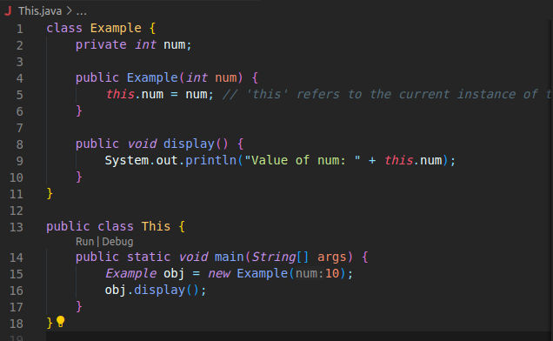
OUTPUT

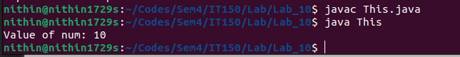

Q4.Write a JAVA program with Multiple constructors (constructor overloading) where
i. 1
st constructor is with multiple parameters,
ii. 2
nd constructor with one parameter defined and others as default values.
iii. 3
rd constructor in terms of another object.
iv. Default constructor (without any arguments)
➢ In the above program, use this keyword for multiple constructors and obtain the output.
Provide your explanation of the outcomes with and without the use this keyword

CODE

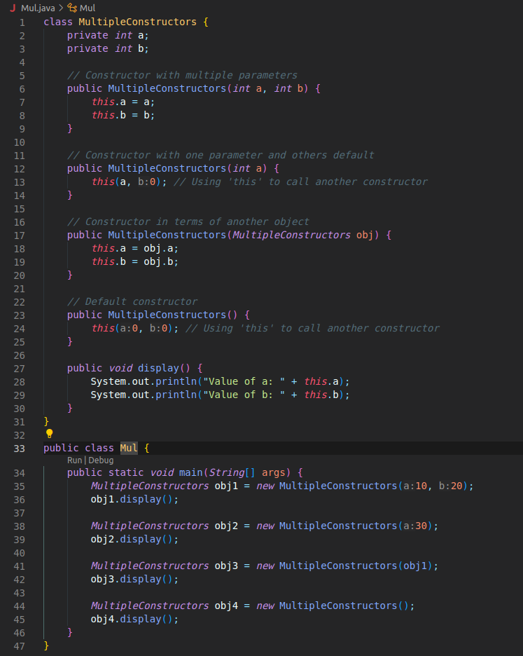

OUTPUT

